# Convolutional Neural Networks

MLP vs CNN

* MLP only use fully connected layers and only accept vectors as input (throws away all the 2-d contained in the image)
* The spatial information or knowledge of the pixels are located in reference to each other could aid significantly towards elucidating the patterns contained in the pixel values
* CNNs also use sparsely connected layers. Where the connection between layers are informed by the 2-D structure of the image matrix(In MLP all hidden node is connected between to every pixel in the original image)

CNNs accept matrix as a input. Locally connected layers less prone to over fitting and truly understands how to tease out the patterns contained in the image data.

Each node is confined to analyse a single small region in the image

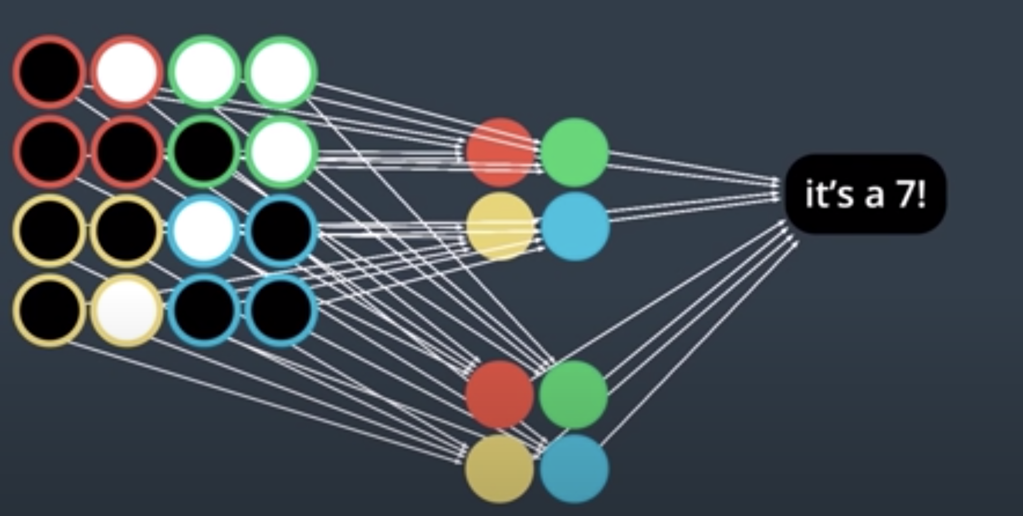

The basic neural network only look at individual inputs. CNNs can look at an image as a whole, or in patches and analyse group of pixels at a time

A convolutional layer applies a series of different image filters also known as convolutional kernels to an input image

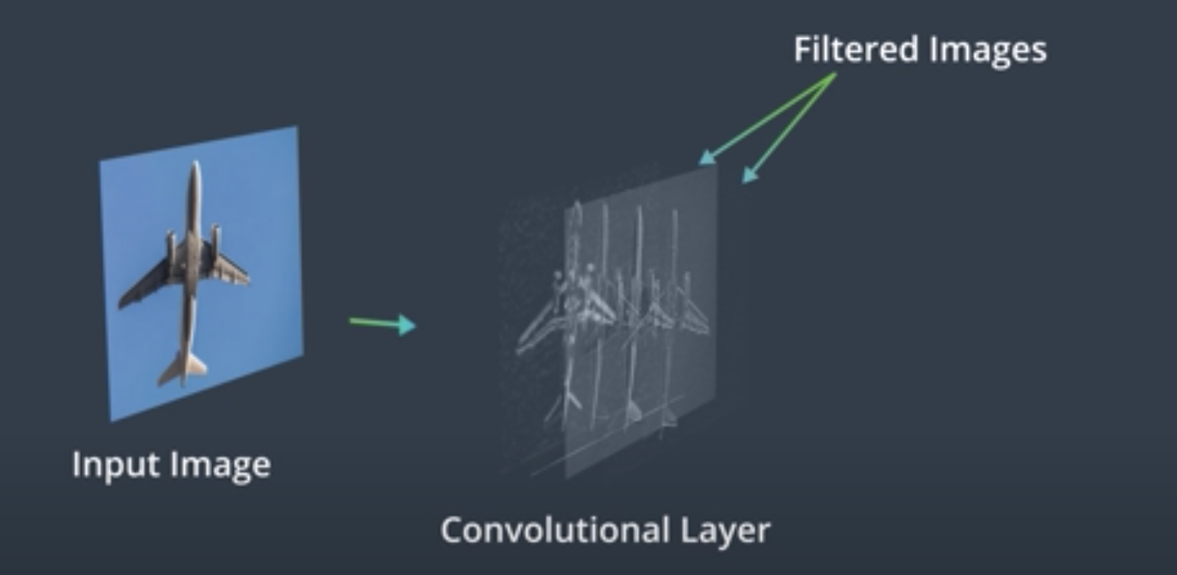

The filters may have extracted features like the edges of objects in that image or the colours that distinguish the different classes of images

Filters and Edges

Filters

* Filter out unwanted information
* Amplify features of interest like object boundaries or other distinguishable traits

The frequency in images is a **rate of change**. But, what does it means for an image to change? Well, images change in space, and a high frequency image is one where the intensity changes a lot. And the level of brightness changes quickly from one pixel to the next. A low frequency image may be one that is relatively uniform in brightness or changes very slowly. This is easiest to see in an example.

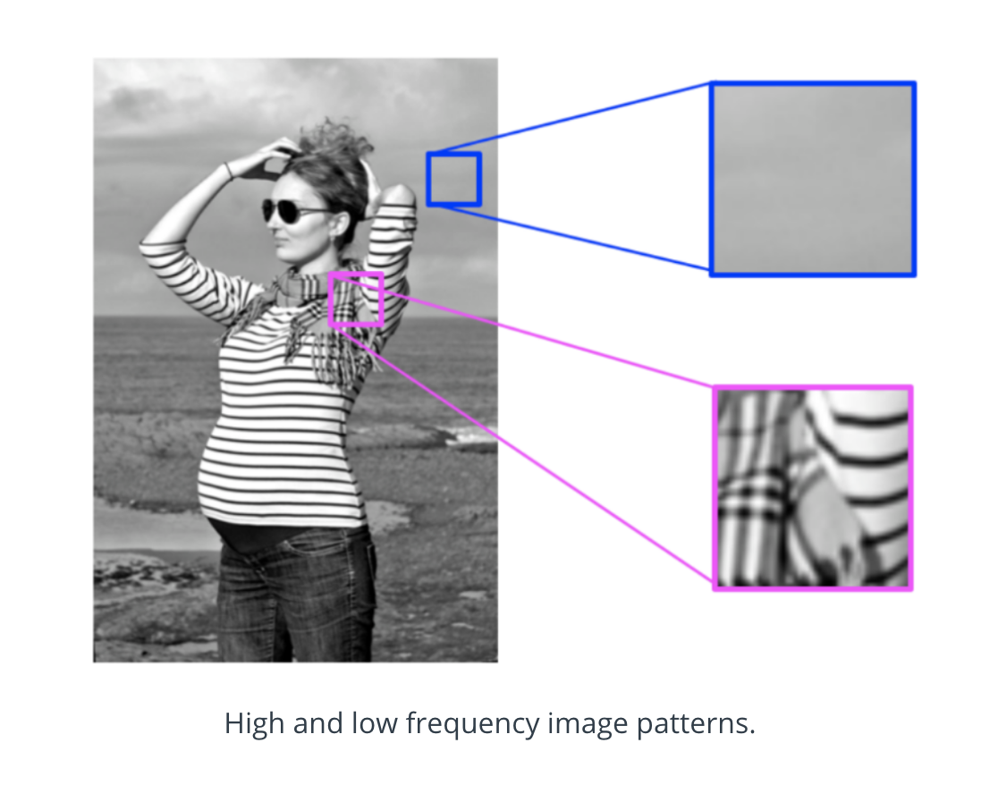

**High-frequency components also correspond to the edges of objects in**

**images**, which can help us classify those objects.

High pass filters

* Sharpen an image
* Enhance high frequency parts of an image

High frequency parts of an image are areas were levels of intensity in neighbouring pixels rapidly change like from very dark to very light pixels. Since we are looking at patterns of intensity, the filters we’ll be working with will be operating on grayscale images that represent this information and display patterns of lightness and darkness in a simple format

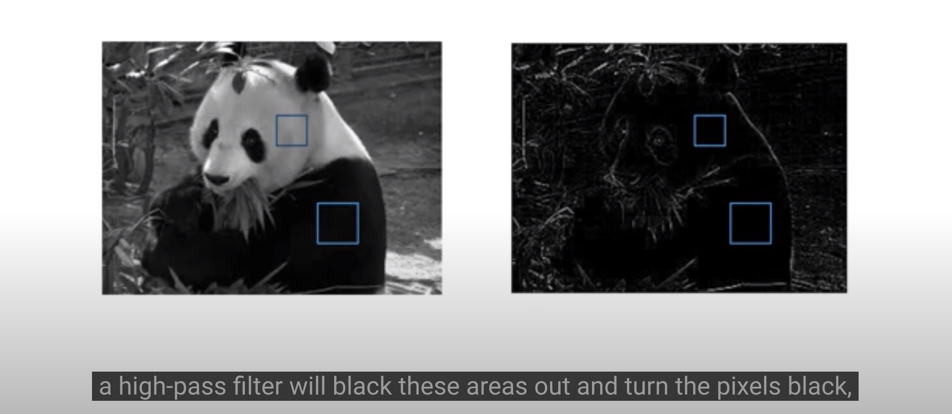

A kernel is a matrix of numbers that modify an image. It’s important for edge detection all of the elements sum to zero as this filter is computing the difference or change between neighbouring pixels and around a centre pixel which help in finding edges

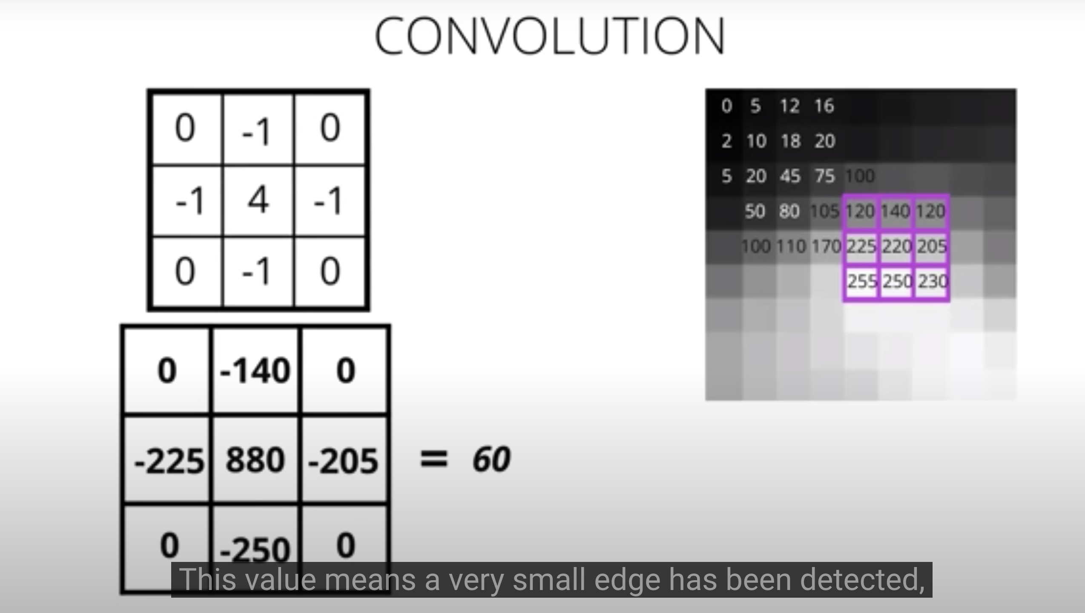

### Edge Handling

Kernel convolution relies on centering a pixel and looking at it's surrounding neighbors. So, what do you do if there are no surrounding pixels like on an image corner or edge? Well, there are a number of ways to process the edges, which are listed below. It’s most common to use padding, cropping, or extension. In extension, the border pixels of an image are copied and extended far enough to result in a filtered image of the same size as the original image.

**Extend** The nearest border pixels are conceptually extended as far as necessary to provide values for the convolution. Corner pixels are extended in 90° wedges. Other edge pixels are extended in lines.

**Padding** The image is padded with a border of 0's, black pixels.

**Crop** Any pixel in the output image which would require values from beyond the edge is skipped. This method can result in the output image being slightly smaller, with the edges having been cropped

Convolutional Layers

CNNs are a kind of deep learning model that can learn to do things like image classification and object recognition. They keep track of spatial information and *learn* to extract features like the edges of objects in something called a **convolutional layer**. Below you'll see an simple CNN structure, made of multiple layers, below, including this "convolutional layer".

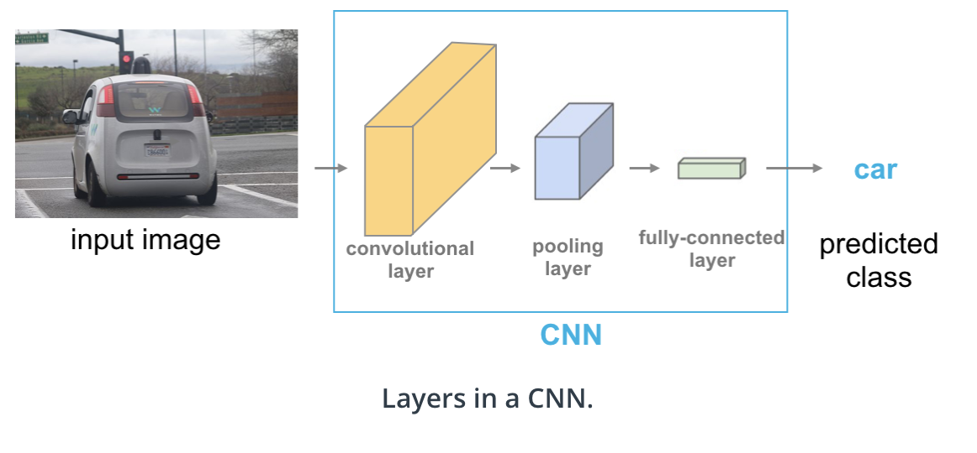

### Pooling Layers

Pooling layers reduce dimensionality( Higher dimensionality leads to overfitting)

Its function is to progressively reduce the spatial size of the representation to reduce the amount of parameters and computation in the network. Pooling layer operates on each feature map independently

Max pooling layer

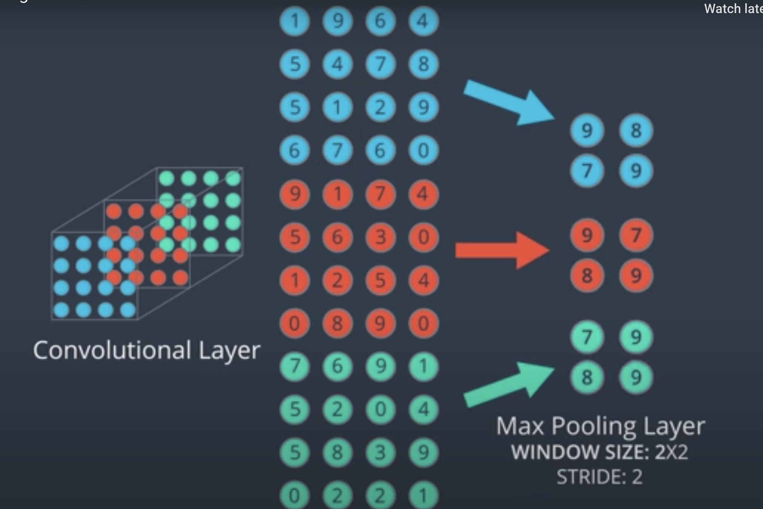

Average pooling

Average pooling averages pixel values in a given window size. So in a 2x2 window, this operation will see 4 pixel values, and return a single, average of those four values, as output!

This kind of pooling is typically not used for image classification problems because max pooling is better at noticing the most important details about edges and other features in an image, but you may see this used in applications for which *smoothing* an image is preferable.

### Alternatives to Pooling

It's important to note that pooling operations do throw away some image information. That is, they discard pixel information in order to get a smaller, feature-level representation of an image. This works quite well in tasks like image classification, but it can cause some issues.

Consider the case of facial recognition. When you think of how you identify a face, you might think about noticing features; two eyes, a nose, and a mouth, for example. And those pieces, together, form a complete face! A typical CNN that is trained to do facial recognition, should also learn to identify these features. Only, by distilling an image into a feature-level representation, you might get a weird result:

Capsule Networks

Capsule Networks provide a way to detect parts of objects in an image and represent spatial relationships between those parts. This means that capsule networks are able to recognize the same object, like a face, in a variety of different poses and with the typical number of features (eyes, nose , mouth) even if they have not seen that pose in training data.

Capsule networks are made of parent and child nodes that build up a complete picture of an object.

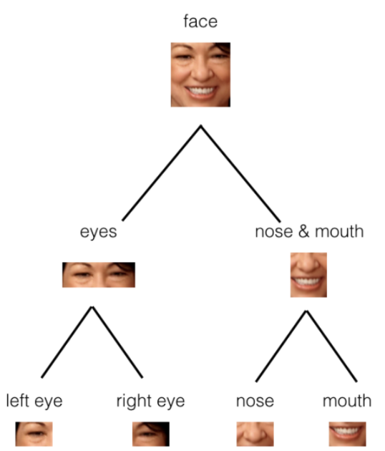

Capsules are essentially a collection of nodes, each of which contains information about a specific part; part properties like width, orientation, color, and so on. The important thing to note is that each capsule **outputs a vector** with some magnitude and orientation.

* Magnitude (m) = the probability that a part exists; a value between 0 and 1.
* Orientation (theta) = the state of the part properties.

These output vectors allow us to do some powerful routing math to build up a parse tree that recognizes whole objects as comprised of several, smaller parts!

The magnitude is a special part property that should stay very high even when an object is in a different orientation, as shown below.

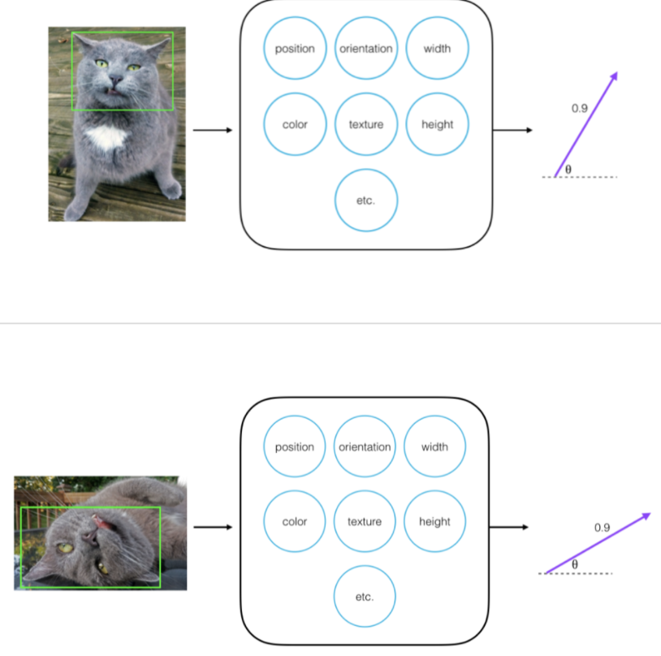

CNN for image classification

The CNN architecture will be designed with a goal of taking that array and gradually making it much deeper than it is tall or wide. Convolutional layers will be used to make the array deeper as it passes through the network, and max pooling layer will be used

To decrease the XY dimensions. As the network gets deeper it’s actually extracting more and more complex patterns and features that help identify the contents and objects in an image and is actually discarding some special information about features like a smooth background and so on.

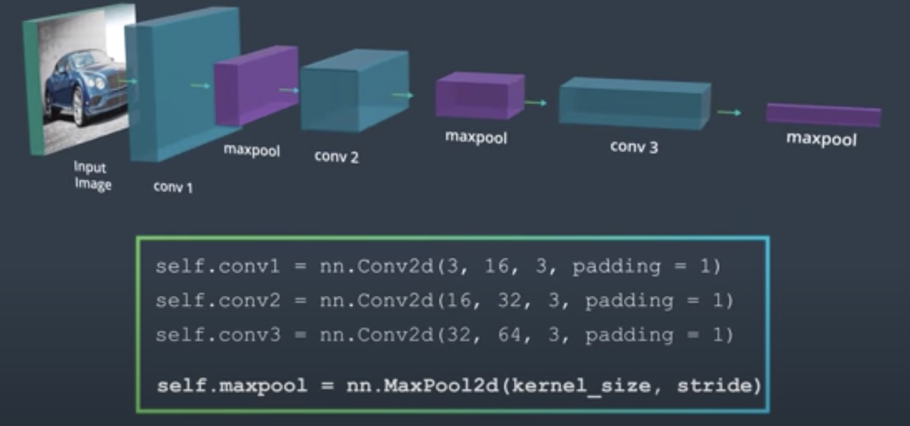

We can compute the spatial size of the output volume as a function of the input volume size (W), the kernel/filter size (F), the stride with which they are applied (S), and the amount of zero padding used (P) on the border. The correct formula for calculating how many neurons define the output_W is given by (W−F+2P)/S+1

For example for a 7x7 input and a 3x3 filter with stride 1 and pad 0 we would get a 5x5 output. With stride 2 we would get a 3x3 output.

(<https://cs231n.github.io/convolutional-networks/#conv>)

**Convolutional Layers in PyTorch**

To create a convolutional layer in PyTorch, you must first import the necessary module:

**import** torch.nn **as** nn

Then, there is a two part process to defining a convolutional layer and defining the feedforward behavior of a model (how an input moves through the layers of a network). First, you must define a Model class and fill in two functions.

**init**

You can define a convolutional layer in the __init__ function of by using the following format:

self.conv1 = nn.Conv2d(in_channels, out_channels, kernel_size, stride=1, padding=0)

**forward**

Then, you refer to that layer in the forward function! Here, I am passing in an input image x and applying a ReLU function to the output of this layer.

x = F.relu(**self**.conv1(x))

**Arguments**

You must pass the following arguments:

* in_channels - The number of inputs (in depth), 3 for an RGB image, for example.
* out_channels - The number of output channels, i.e. the number of filtered "images" a convolutional layer is made of or the number of unique, convolutional kernels that will be applied to an input.
* kernel_size - Number specifying both the height and width of the (square) convolutional kernel.

There are some additional, optional arguments that you might like to tune:

* stride - The stride of the convolution. If you don't specify anything, stride is set to 1.
* padding - The border of 0's around an input array. If you don't specify anything, padding is set to 0.

**NOTE**: It is possible to represent both kernel_size and stride as either a number or a tuple.

There are many other tunable arguments that you can set to change the behavior of your convolutional layers. To read more about these, we recommend perusing the official [**documentation**](https://pytorch.org/docs/stable/nn.html#conv2d).

**Pooling Layers**

Pooling layers take in a kernel_size and a stride. Typically the same value as is the down-sampling factor. For example, the following code will down-sample an input's x-y dimensions, by a factor of 2:

self.pool = nn.MaxPool2d(2,2)

**forward**

Here, we see that poling layer being applied in the forward function.

x = F.relu(**self**.conv1(x))

x = **self**.pool(x)

We can also create a CNN in PyTorch by using a Sequential wrapper in the __init__ function. Sequential allows us to stack different types of layers, specifying activation functions in between!

**def** **__init__**(self):

super(ModelName, self).__init__()

self.features = nn.Sequential(

nn.Conv2d(1, 16, 2, stride=2),

nn.MaxPool2d(2, 2),

nn.ReLU(**True**),

nn.Conv2d(16, 32, 3, padding=1),

nn.MaxPool2d(2, 2),

nn.ReLU(**True**)

)

Data Augmentation

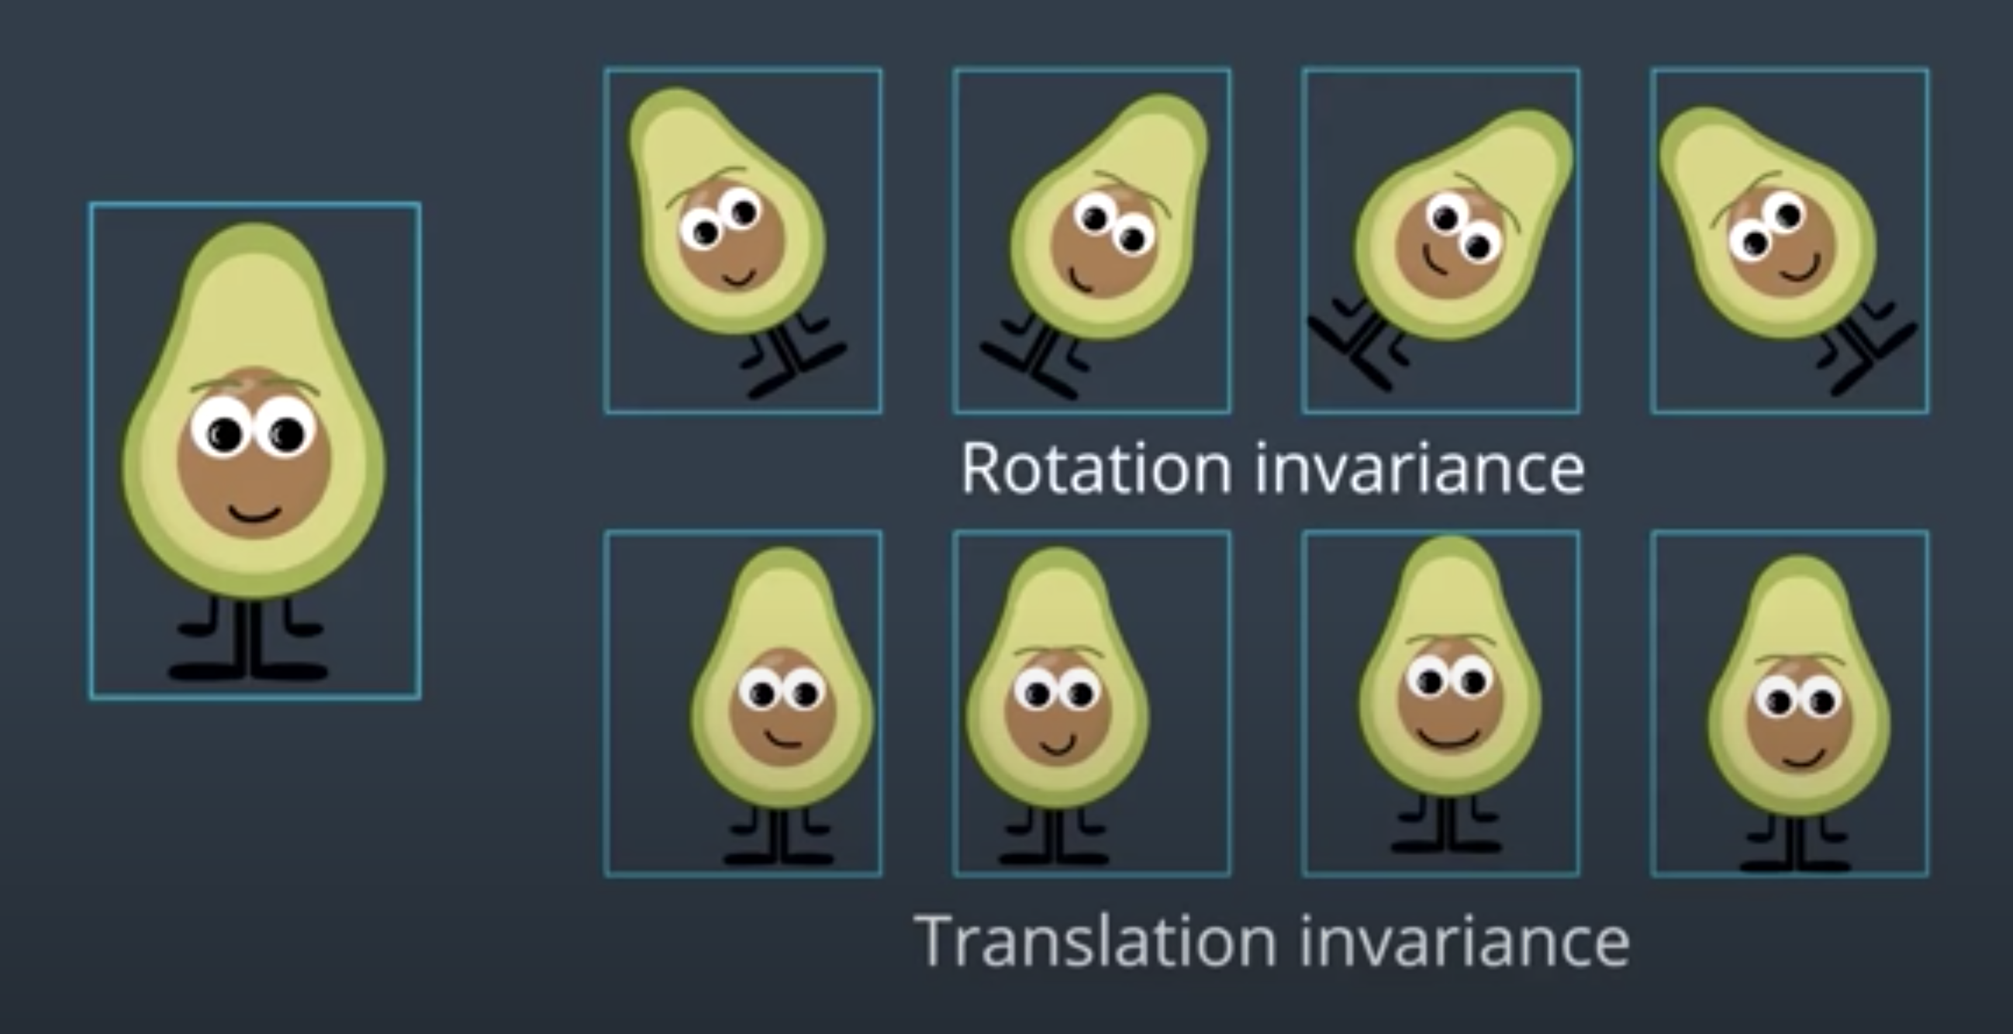

Data augmentation will help us avoid overfitting. Thus, it would be better at generalizing and we should see better performance on the test dataset

**Visualizing CNNs**

Let’s look at an example CNN to see how it works in action.

The CNN we will look at is trained on ImageNet as described in [this paper](hhttps://cs.nyu.edu/~fergus/papers/zeilerECCV2014.pdf) by Zeiler and Fergus. In the images below (from the same paper), we’ll see *what* each layer in this network detects and see *how* each layer detects more and more complex ideas.

[[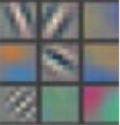](https://classroom.udacity.com/nanodegrees/nd101/parts/2e8d3b5d-aa70-4376-946f-0cdc37127d7d/modules/19a75d10-547d-4497-ae68-609ca1a235fc/lessons/807590ea-abd5-4581-b91d-9eede9a0aad2/concepts/cbf65dc4-c0b4-44c5-81c6-5997e409cb75)](https://classroom.udacity.com/nanodegrees/nd101/parts/2e8d3b5d-aa70-4376-946f-0cdc37127d7d/modules/19a75d10-547d-4497-ae68-609ca1a235fc/lessons/807590ea-abd5-4581-b91d-9eede9a0aad2/concepts/cbf65dc4-c0b4-44c5-81c6-5997e409cb75)

[Example patterns that cause activations in the first layer of the network. These range from simple diagonal lines (top left) to green blobs (bottom middle).](https://classroom.udacity.com/nanodegrees/nd101/parts/2e8d3b5d-aa70-4376-946f-0cdc37127d7d/modules/19a75d10-547d-4497-ae68-609ca1a235fc/lessons/807590ea-abd5-4581-b91d-9eede9a0aad2/concepts/cbf65dc4-c0b4-44c5-81c6-5997e409cb75)

The images above are from Matthew Zeiler and Rob Fergus' [deep visualization toolbox](https://www.youtube.com/watch?v=ghEmQSxT6tw), which lets us visualize what each layer in a CNN focuses on.

Each image in the above grid represents a pattern that causes the neurons in the first layer to activate - in other words, they are patterns that the first layer recognizes. The top left image shows a -45 degree line, while the middle top square shows a +45 degree line. These squares are shown below again for reference.

[[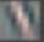](https://classroom.udacity.com/nanodegrees/nd101/parts/2e8d3b5d-aa70-4376-946f-0cdc37127d7d/modules/19a75d10-547d-4497-ae68-609ca1a235fc/lessons/807590ea-abd5-4581-b91d-9eede9a0aad2/concepts/cbf65dc4-c0b4-44c5-81c6-5997e409cb75)](https://classroom.udacity.com/nanodegrees/nd101/parts/2e8d3b5d-aa70-4376-946f-0cdc37127d7d/modules/19a75d10-547d-4497-ae68-609ca1a235fc/lessons/807590ea-abd5-4581-b91d-9eede9a0aad2/concepts/cbf65dc4-c0b4-44c5-81c6-5997e409cb75)

[As visualized here, the first layer of the CNN can recognize -45 degree lines.](https://classroom.udacity.com/nanodegrees/nd101/parts/2e8d3b5d-aa70-4376-946f-0cdc37127d7d/modules/19a75d10-547d-4497-ae68-609ca1a235fc/lessons/807590ea-abd5-4581-b91d-9eede9a0aad2/concepts/cbf65dc4-c0b4-44c5-81c6-5997e409cb75)

[[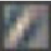](https://classroom.udacity.com/nanodegrees/nd101/parts/2e8d3b5d-aa70-4376-946f-0cdc37127d7d/modules/19a75d10-547d-4497-ae68-609ca1a235fc/lessons/807590ea-abd5-4581-b91d-9eede9a0aad2/concepts/cbf65dc4-c0b4-44c5-81c6-5997e409cb75)](https://classroom.udacity.com/nanodegrees/nd101/parts/2e8d3b5d-aa70-4376-946f-0cdc37127d7d/modules/19a75d10-547d-4497-ae68-609ca1a235fc/lessons/807590ea-abd5-4581-b91d-9eede9a0aad2/concepts/cbf65dc4-c0b4-44c5-81c6-5997e409cb75)

[The first layer of the CNN is also able to recognize +45 degree lines, like the one above.](https://classroom.udacity.com/nanodegrees/nd101/parts/2e8d3b5d-aa70-4376-946f-0cdc37127d7d/modules/19a75d10-547d-4497-ae68-609ca1a235fc/lessons/807590ea-abd5-4581-b91d-9eede9a0aad2/concepts/cbf65dc4-c0b4-44c5-81c6-5997e409cb75)

Let's now see some example images that cause such activations. The below grid of images all activated the -45 degree line. Notice how they are all selected despite the fact that they have different colors, gradients, and patterns.

[[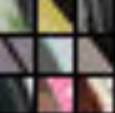](https://classroom.udacity.com/nanodegrees/nd101/parts/2e8d3b5d-aa70-4376-946f-0cdc37127d7d/modules/19a75d10-547d-4497-ae68-609ca1a235fc/lessons/807590ea-abd5-4581-b91d-9eede9a0aad2/concepts/cbf65dc4-c0b4-44c5-81c6-5997e409cb75)](https://classroom.udacity.com/nanodegrees/nd101/parts/2e8d3b5d-aa70-4376-946f-0cdc37127d7d/modules/19a75d10-547d-4497-ae68-609ca1a235fc/lessons/807590ea-abd5-4581-b91d-9eede9a0aad2/concepts/cbf65dc4-c0b4-44c5-81c6-5997e409cb75)

[Example patches that activate the -45 degree line detector in the first layer.](https://classroom.udacity.com/nanodegrees/nd101/parts/2e8d3b5d-aa70-4376-946f-0cdc37127d7d/modules/19a75d10-547d-4497-ae68-609ca1a235fc/lessons/807590ea-abd5-4581-b91d-9eede9a0aad2/concepts/cbf65dc4-c0b4-44c5-81c6-5997e409cb75)

So, the first layer of our CNN clearly picks out very simple shapes and patterns like lines and blobs.

**Layer 2**

[[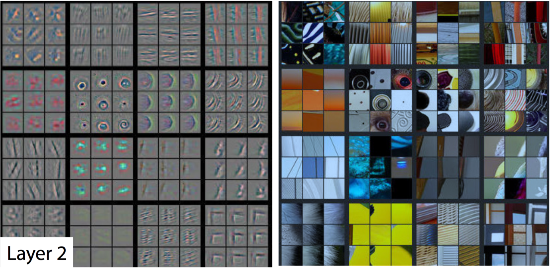](https://classroom.udacity.com/nanodegrees/nd101/parts/2e8d3b5d-aa70-4376-946f-0cdc37127d7d/modules/19a75d10-547d-4497-ae68-609ca1a235fc/lessons/807590ea-abd5-4581-b91d-9eede9a0aad2/concepts/cbf65dc4-c0b4-44c5-81c6-5997e409cb75)](https://classroom.udacity.com/nanodegrees/nd101/parts/2e8d3b5d-aa70-4376-946f-0cdc37127d7d/modules/19a75d10-547d-4497-ae68-609ca1a235fc/lessons/807590ea-abd5-4581-b91d-9eede9a0aad2/concepts/cbf65dc4-c0b4-44c5-81c6-5997e409cb75)

[A visualization of the second layer in the CNN. Notice how we are picking up more complex ideas like circles and stripes. The gray grid on the left represents how this layer of the CNN activates (or "what it sees") based on the corresponding images from the grid on the right.](https://classroom.udacity.com/nanodegrees/nd101/parts/2e8d3b5d-aa70-4376-946f-0cdc37127d7d/modules/19a75d10-547d-4497-ae68-609ca1a235fc/lessons/807590ea-abd5-4581-b91d-9eede9a0aad2/concepts/cbf65dc4-c0b4-44c5-81c6-5997e409cb75)

The second layer of the CNN captures complex ideas.

As you see in the image above, the second layer of the CNN recognizes circles (second row, second column), stripes (first row, second column), and rectangles (bottom right).

**The CNN learns to do this on its own.** There is no special instruction for the CNN to focus on more complex objects in deeper layers. That's just how it normally works out when you feed training data into a CNN.

**Layer 3**

[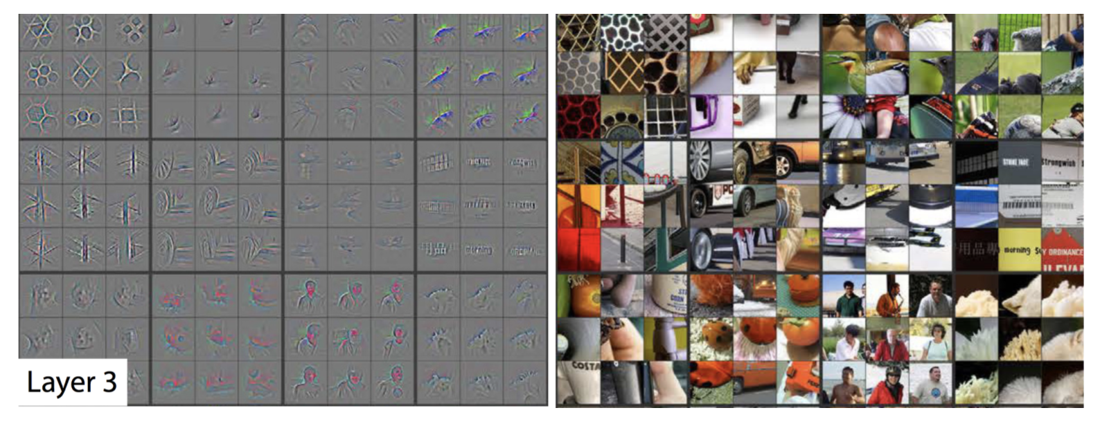](https://classroom.udacity.com/nanodegrees/nd101/parts/2e8d3b5d-aa70-4376-946f-0cdc37127d7d/modules/19a75d10-547d-4497-ae68-609ca1a235fc/lessons/807590ea-abd5-4581-b91d-9eede9a0aad2/concepts/cbf65dc4-c0b4-44c5-81c6-5997e409cb75)

[A visualization of the third layer in the CNN. The gray grid on the left represents how this layer of the CNN activates (or "what it sees") based on the corresponding images from the grid on the right.](https://classroom.udacity.com/nanodegrees/nd101/parts/2e8d3b5d-aa70-4376-946f-0cdc37127d7d/modules/19a75d10-547d-4497-ae68-609ca1a235fc/lessons/807590ea-abd5-4581-b91d-9eede9a0aad2/concepts/cbf65dc4-c0b4-44c5-81c6-5997e409cb75)

The third layer picks out complex combinations of features from the second layer. These include things like grids, and honeycombs (top left), wheels (second row, second column), and even faces (third row, third column).

We'll skip layer 4, which continues this progression, and jump right to the fifth and final layer of this CNN.

**Layer 5**

[[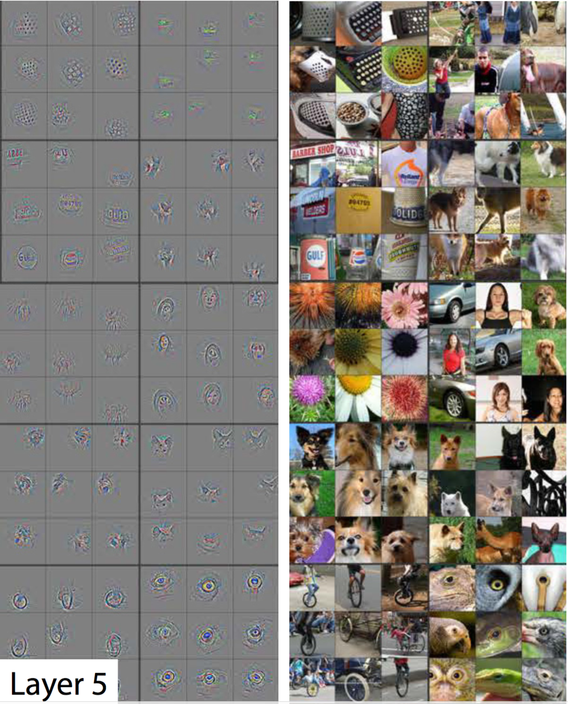](https://classroom.udacity.com/nanodegrees/nd101/parts/2e8d3b5d-aa70-4376-946f-0cdc37127d7d/modules/19a75d10-547d-4497-ae68-609ca1a235fc/lessons/807590ea-abd5-4581-b91d-9eede9a0aad2/concepts/cbf65dc4-c0b4-44c5-81c6-5997e409cb75)](https://classroom.udacity.com/nanodegrees/nd101/parts/2e8d3b5d-aa70-4376-946f-0cdc37127d7d/modules/19a75d10-547d-4497-ae68-609ca1a235fc/lessons/807590ea-abd5-4581-b91d-9eede9a0aad2/concepts/cbf65dc4-c0b4-44c5-81c6-5997e409cb75)

[A visualization of the fifth and final layer of the CNN. The gray grid on the left represents how this layer of the CNN activates (or "what it sees") based on the corresponding images from the grid on the right.](https://classroom.udacity.com/nanodegrees/nd101/parts/2e8d3b5d-aa70-4376-946f-0cdc37127d7d/modules/19a75d10-547d-4497-ae68-609ca1a235fc/lessons/807590ea-abd5-4581-b91d-9eede9a0aad2/concepts/cbf65dc4-c0b4-44c5-81c6-5997e409cb75)

The last layer picks out the highest order ideas that we care about for classification, like dog faces, bird faces, and bicycles.

# Transfer Learning

Transfer learning involves taking a pre-trained neural network and adapting the neural network to a new, different data set.

(<https://cs231n.github.io/transfer-learning/>)

Depending on both:

* The size of the new data set, and
* The similarity of the new data set to the original data set

The approach for using transfer learning will be different. There are four main cases:

1. New data set is small, new data is similar to original training data.
2. New data set is small, new data is different from original training data.
3. New data set is large, new data is similar to original training data.
4. New data set is large, new data is different from original training data.

A large data set might have one million images. A small data could have two-thousand images. The dividing line between a large data set and small data set is somewhat subjective. Overfitting is a concern when using transfer learning with a small data set.

Images of dogs and images of wolves would be considered similar; the images would share common characteristics. A data set of flower images would be different from a data set of dog images.

Each of the four transfer learning cases has its own approach. In the following sections, we will look at each case one by one.

The graph below displays what approach is recommended for each of the four main cases.

**[[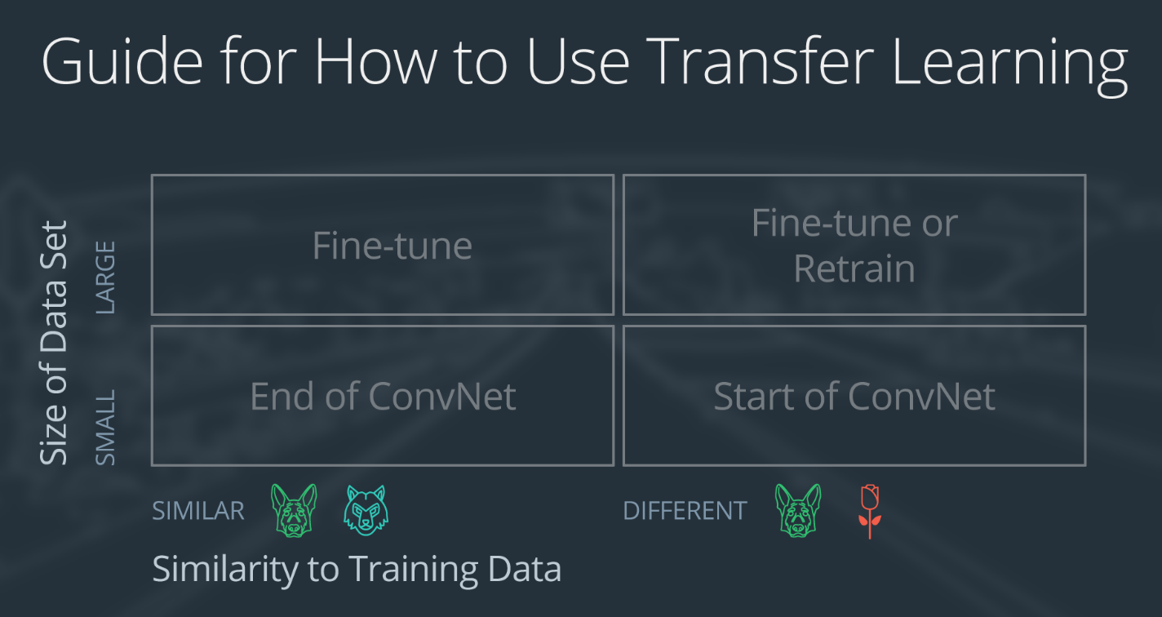](https://classroom.udacity.com/nanodegrees/nd101/parts/2e8d3b5d-aa70-4376-946f-0cdc37127d7d/modules/19a75d10-547d-4497-ae68-609ca1a235fc/lessons/a559990d-e214-4c5d-a424-437f6299383e/concepts/f80c5e76-e812-4bb0-aecd-40921aaf0bf6)](https://classroom.udacity.com/nanodegrees/nd101/parts/2e8d3b5d-aa70-4376-946f-0cdc37127d7d/modules/19a75d10-547d-4497-ae68-609ca1a235fc/lessons/a559990d-e214-4c5d-a424-437f6299383e/concepts/f80c5e76-e812-4bb0-aecd-40921aaf0bf6)**

**[Four cases for using transfer learning.](https://classroom.udacity.com/nanodegrees/nd101/parts/2e8d3b5d-aa70-4376-946f-0cdc37127d7d/modules/19a75d10-547d-4497-ae68-609ca1a235fc/lessons/a559990d-e214-4c5d-a424-437f6299383e/concepts/f80c5e76-e812-4bb0-aecd-40921aaf0bf6)**

### Demonstration Network

To explain how each situation works, we will start with a generic pre-trained convolutional neural network and explain how to adjust the network for each case. Our example network contains three convolutional layers and three fully connected layers:

**[[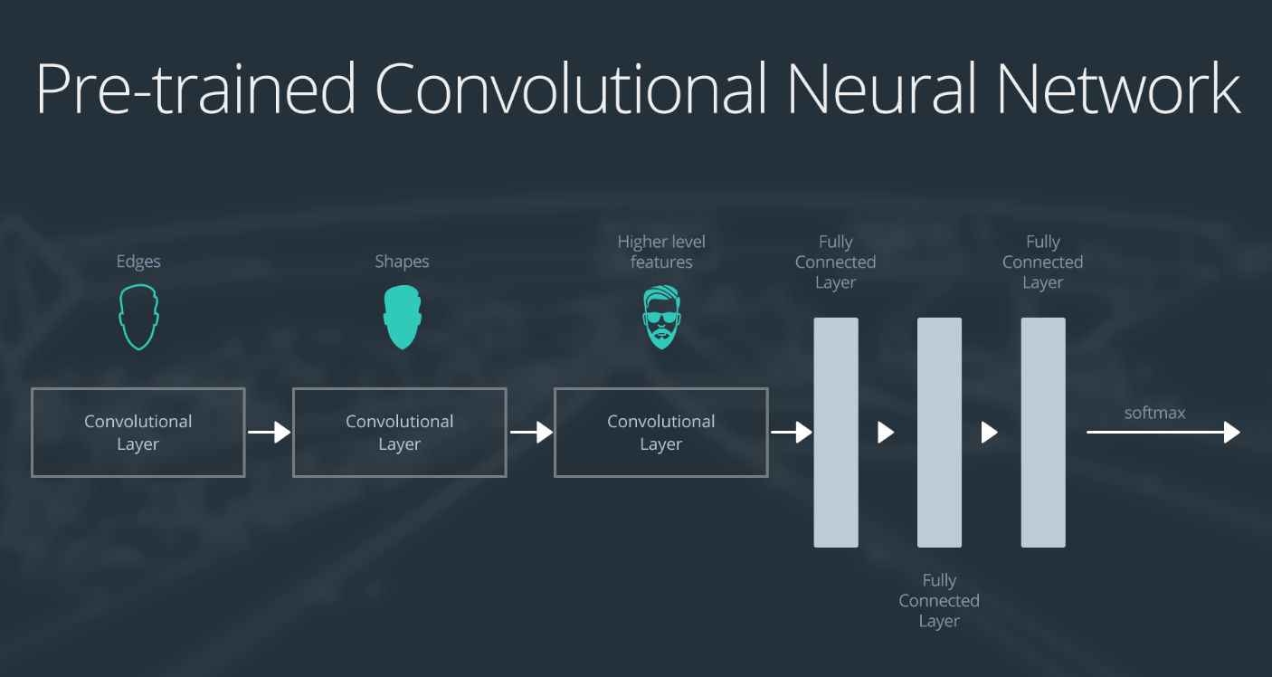](https://classroom.udacity.com/nanodegrees/nd101/parts/2e8d3b5d-aa70-4376-946f-0cdc37127d7d/modules/19a75d10-547d-4497-ae68-609ca1a235fc/lessons/a559990d-e214-4c5d-a424-437f6299383e/concepts/f80c5e76-e812-4bb0-aecd-40921aaf0bf6)](https://classroom.udacity.com/nanodegrees/nd101/parts/2e8d3b5d-aa70-4376-946f-0cdc37127d7d/modules/19a75d10-547d-4497-ae68-609ca1a235fc/lessons/a559990d-e214-4c5d-a424-437f6299383e/concepts/f80c5e76-e812-4bb0-aecd-40921aaf0bf6)**

**[Overview of the layers of a pre-trained CNN.](https://classroom.udacity.com/nanodegrees/nd101/parts/2e8d3b5d-aa70-4376-946f-0cdc37127d7d/modules/19a75d10-547d-4497-ae68-609ca1a235fc/lessons/a559990d-e214-4c5d-a424-437f6299383e/concepts/f80c5e76-e812-4bb0-aecd-40921aaf0bf6)**

Here is an generalized overview of what the convolutional neural network does:

* the first layer will detect edges in the image
* the second layer will detect shapes
* the third convolutional layer detects higher level features

Each transfer learning case will use the pre-trained convolutional neural network in a different way.

### Case 1: Small Data Set, Similar Data

**[[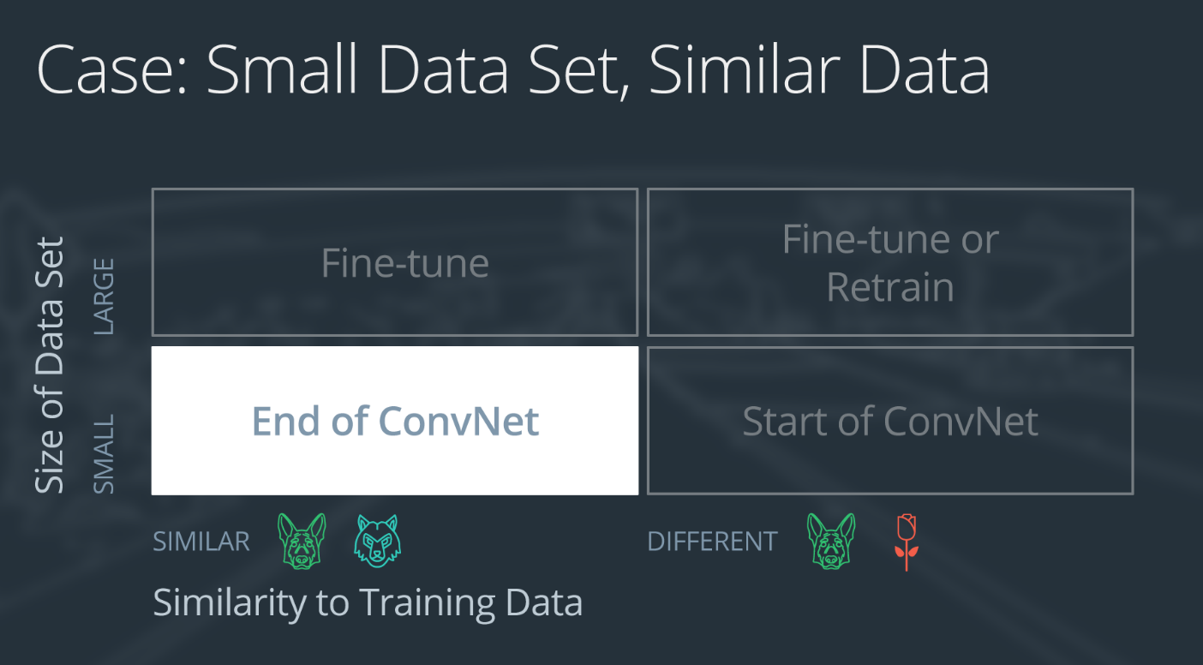](https://classroom.udacity.com/nanodegrees/nd101/parts/2e8d3b5d-aa70-4376-946f-0cdc37127d7d/modules/19a75d10-547d-4497-ae68-609ca1a235fc/lessons/a559990d-e214-4c5d-a424-437f6299383e/concepts/f80c5e76-e812-4bb0-aecd-40921aaf0bf6)](https://classroom.udacity.com/nanodegrees/nd101/parts/2e8d3b5d-aa70-4376-946f-0cdc37127d7d/modules/19a75d10-547d-4497-ae68-609ca1a235fc/lessons/a559990d-e214-4c5d-a424-437f6299383e/concepts/f80c5e76-e812-4bb0-aecd-40921aaf0bf6)**

**[Case 1: small set, similar data](https://classroom.udacity.com/nanodegrees/nd101/parts/2e8d3b5d-aa70-4376-946f-0cdc37127d7d/modules/19a75d10-547d-4497-ae68-609ca1a235fc/lessons/a559990d-e214-4c5d-a424-437f6299383e/concepts/f80c5e76-e812-4bb0-aecd-40921aaf0bf6)**

If the new data set is small and similar to the original training data:

* slice off the end of the neural network
* add a new fully connected layer that matches the number of classes in the new data set
* randomize the weights of the new fully connected layer; freeze all the weights from the pre-trained network
* train the network to update the weights of the new fully connected layer

To avoid overfitting on the small data set, the weights of the original network will be held constant rather than re-training the weights.

Since the data sets are similar, images from each data set will have similar higher level features. Therefore most or all of the pre-trained neural network layers already contain relevant information about the new data set and should be kept.

Here's how to visualize this approach:

**[[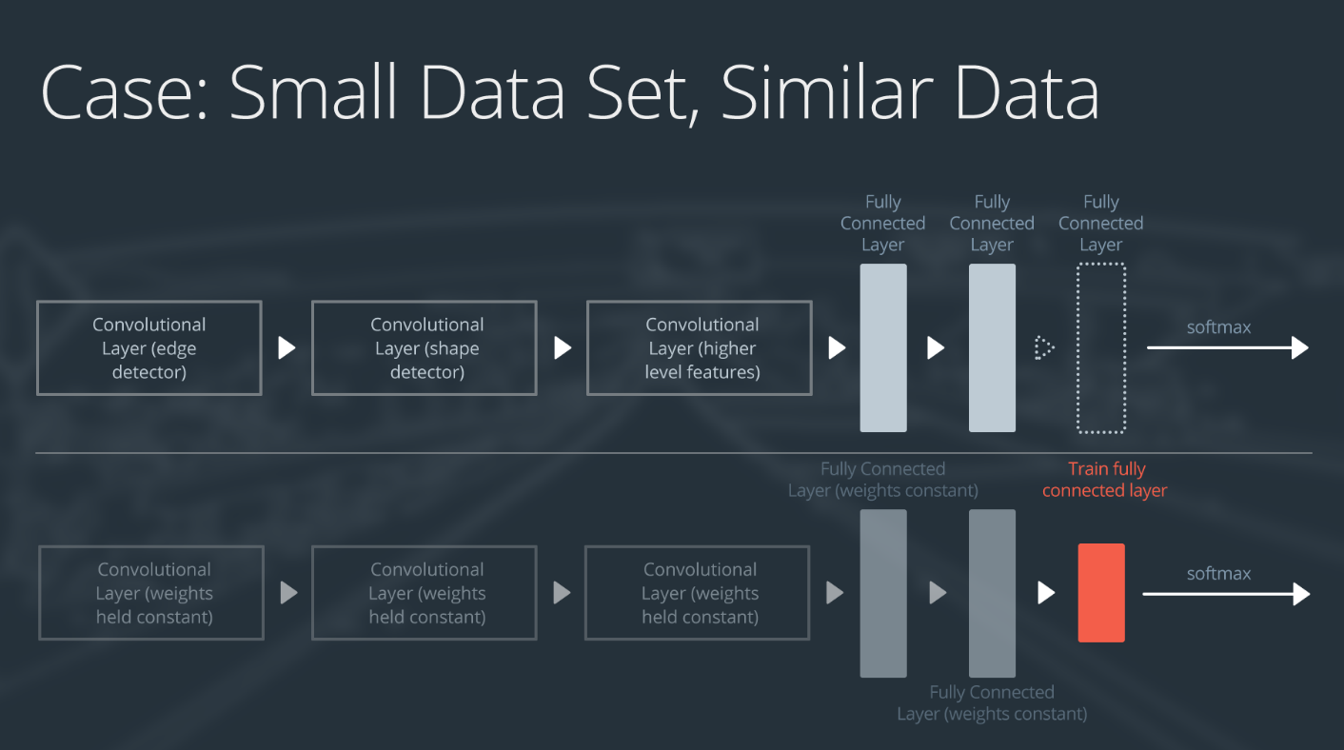](https://classroom.udacity.com/nanodegrees/nd101/parts/2e8d3b5d-aa70-4376-946f-0cdc37127d7d/modules/19a75d10-547d-4497-ae68-609ca1a235fc/lessons/a559990d-e214-4c5d-a424-437f6299383e/concepts/f80c5e76-e812-4bb0-aecd-40921aaf0bf6)](https://classroom.udacity.com/nanodegrees/nd101/parts/2e8d3b5d-aa70-4376-946f-0cdc37127d7d/modules/19a75d10-547d-4497-ae68-609ca1a235fc/lessons/a559990d-e214-4c5d-a424-437f6299383e/concepts/f80c5e76-e812-4bb0-aecd-40921aaf0bf6)**

**[Adding and training a fully-connected layer at the end of the NN.](https://classroom.udacity.com/nanodegrees/nd101/parts/2e8d3b5d-aa70-4376-946f-0cdc37127d7d/modules/19a75d10-547d-4497-ae68-609ca1a235fc/lessons/a559990d-e214-4c5d-a424-437f6299383e/concepts/f80c5e76-e812-4bb0-aecd-40921aaf0bf6)**

### Case 2: Small Data Set, Different Data

**[[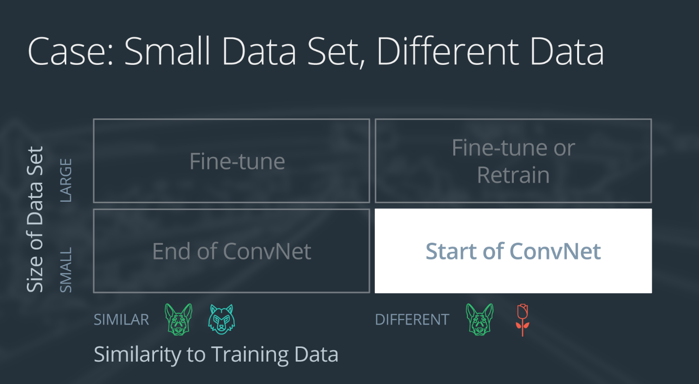](https://classroom.udacity.com/nanodegrees/nd101/parts/2e8d3b5d-aa70-4376-946f-0cdc37127d7d/modules/19a75d10-547d-4497-ae68-609ca1a235fc/lessons/a559990d-e214-4c5d-a424-437f6299383e/concepts/f80c5e76-e812-4bb0-aecd-40921aaf0bf6)](https://classroom.udacity.com/nanodegrees/nd101/parts/2e8d3b5d-aa70-4376-946f-0cdc37127d7d/modules/19a75d10-547d-4497-ae68-609ca1a235fc/lessons/a559990d-e214-4c5d-a424-437f6299383e/concepts/f80c5e76-e812-4bb0-aecd-40921aaf0bf6)**

**[Case 2: small set, different data](https://classroom.udacity.com/nanodegrees/nd101/parts/2e8d3b5d-aa70-4376-946f-0cdc37127d7d/modules/19a75d10-547d-4497-ae68-609ca1a235fc/lessons/a559990d-e214-4c5d-a424-437f6299383e/concepts/f80c5e76-e812-4bb0-aecd-40921aaf0bf6)**

If the new data set is small and different from the original training data:

* slice off all but some of the pre-trained layers near the beginning of the network
* add to the remaining pre-trained layers a new fully connected layer that matches the number of classes in the new data set
* randomize the weights of the new fully connected layer; freeze all the weights from the pre-trained network
* train the network to update the weights of the new fully connected layer

Because the data set is small, overfitting is still a concern. To combat overfitting, the weights of the original neural network will be held constant, like in the first case.

But the original training set and the new data set do not share higher level features. In this case, the new network will only use the layers containing lower level features.

Here is how to visualize this approach:

**[[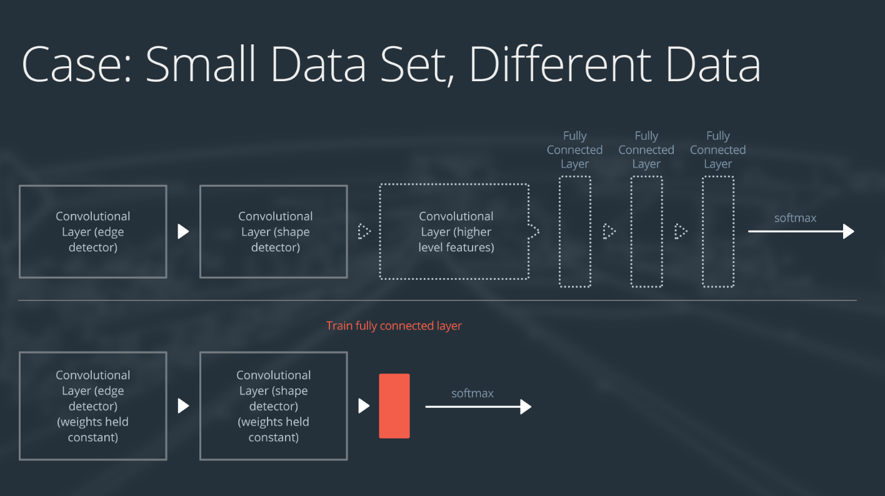](https://classroom.udacity.com/nanodegrees/nd101/parts/2e8d3b5d-aa70-4376-946f-0cdc37127d7d/modules/19a75d10-547d-4497-ae68-609ca1a235fc/lessons/a559990d-e214-4c5d-a424-437f6299383e/concepts/f80c5e76-e812-4bb0-aecd-40921aaf0bf6)](https://classroom.udacity.com/nanodegrees/nd101/parts/2e8d3b5d-aa70-4376-946f-0cdc37127d7d/modules/19a75d10-547d-4497-ae68-609ca1a235fc/lessons/a559990d-e214-4c5d-a424-437f6299383e/concepts/f80c5e76-e812-4bb0-aecd-40921aaf0bf6)**

**[Remove all but the starting layers of the model, and add and train a linear layer at the end.](https://classroom.udacity.com/nanodegrees/nd101/parts/2e8d3b5d-aa70-4376-946f-0cdc37127d7d/modules/19a75d10-547d-4497-ae68-609ca1a235fc/lessons/a559990d-e214-4c5d-a424-437f6299383e/concepts/f80c5e76-e812-4bb0-aecd-40921aaf0bf6)**

### Case 3: Large Data Set, Similar Data

**[[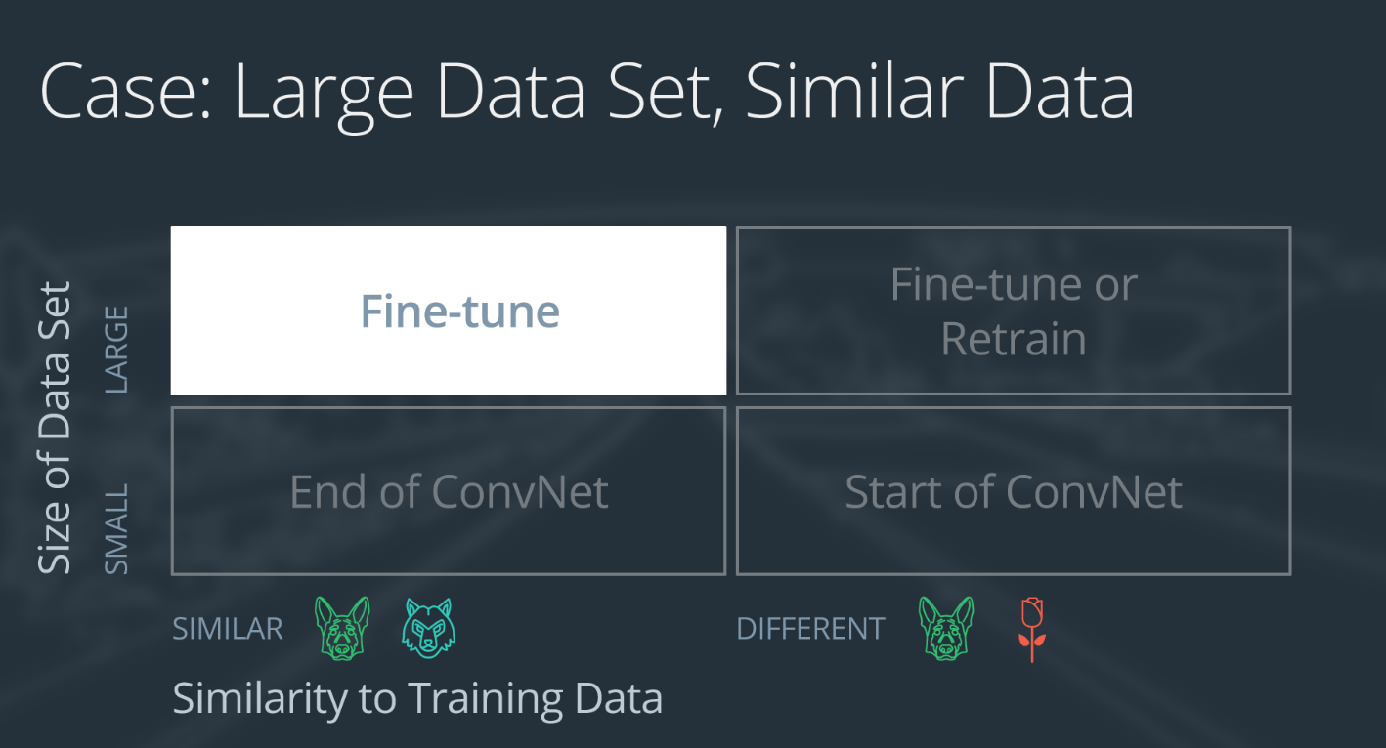](https://classroom.udacity.com/nanodegrees/nd101/parts/2e8d3b5d-aa70-4376-946f-0cdc37127d7d/modules/19a75d10-547d-4497-ae68-609ca1a235fc/lessons/a559990d-e214-4c5d-a424-437f6299383e/concepts/f80c5e76-e812-4bb0-aecd-40921aaf0bf6)](https://classroom.udacity.com/nanodegrees/nd101/parts/2e8d3b5d-aa70-4376-946f-0cdc37127d7d/modules/19a75d10-547d-4497-ae68-609ca1a235fc/lessons/a559990d-e214-4c5d-a424-437f6299383e/concepts/f80c5e76-e812-4bb0-aecd-40921aaf0bf6)**

**[Case 3: large data, similar to ImageNet or pre-trained set.](https://classroom.udacity.com/nanodegrees/nd101/parts/2e8d3b5d-aa70-4376-946f-0cdc37127d7d/modules/19a75d10-547d-4497-ae68-609ca1a235fc/lessons/a559990d-e214-4c5d-a424-437f6299383e/concepts/f80c5e76-e812-4bb0-aecd-40921aaf0bf6)**

If the new data set is large and similar to the original training data:

* remove the last fully connected layer and replace with a layer matching the number of classes in the new data set
* randomly initialize the weights in the new fully connected layer
* initialize the rest of the weights using the pre-trained weights
* re-train the entire neural network

Overfitting is not as much of a concern when training on a large data set; therefore, you can re-train all of the weights.

Because the original training set and the new data set share higher level features, the entire neural network is used as well.

Here is how to visualize this approach:

**[[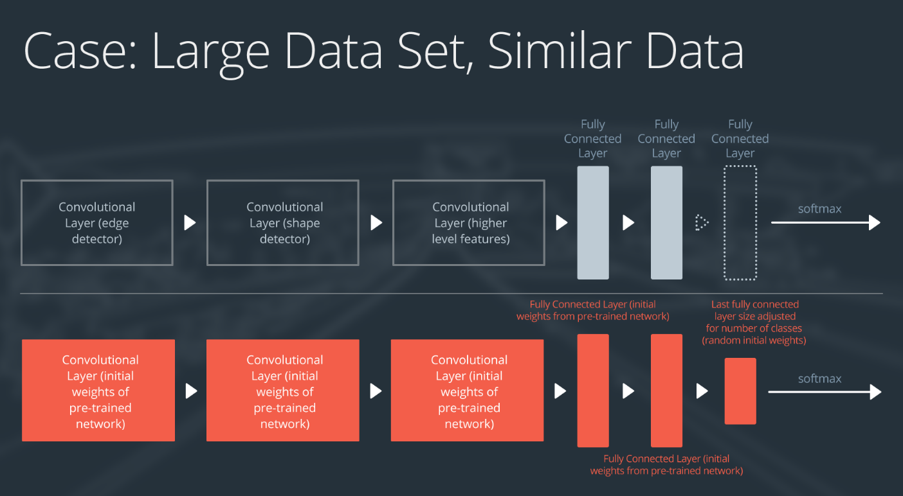](https://classroom.udacity.com/nanodegrees/nd101/parts/2e8d3b5d-aa70-4376-946f-0cdc37127d7d/modules/19a75d10-547d-4497-ae68-609ca1a235fc/lessons/a559990d-e214-4c5d-a424-437f6299383e/concepts/f80c5e76-e812-4bb0-aecd-40921aaf0bf6)](https://classroom.udacity.com/nanodegrees/nd101/parts/2e8d3b5d-aa70-4376-946f-0cdc37127d7d/modules/19a75d10-547d-4497-ae68-609ca1a235fc/lessons/a559990d-e214-4c5d-a424-437f6299383e/concepts/f80c5e76-e812-4bb0-aecd-40921aaf0bf6)**

**[Utilizing pre-trained weights as a starting point!](https://classroom.udacity.com/nanodegrees/nd101/parts/2e8d3b5d-aa70-4376-946f-0cdc37127d7d/modules/19a75d10-547d-4497-ae68-609ca1a235fc/lessons/a559990d-e214-4c5d-a424-437f6299383e/concepts/f80c5e76-e812-4bb0-aecd-40921aaf0bf6)**

### Case 4: Large Data Set, Different Data

**[[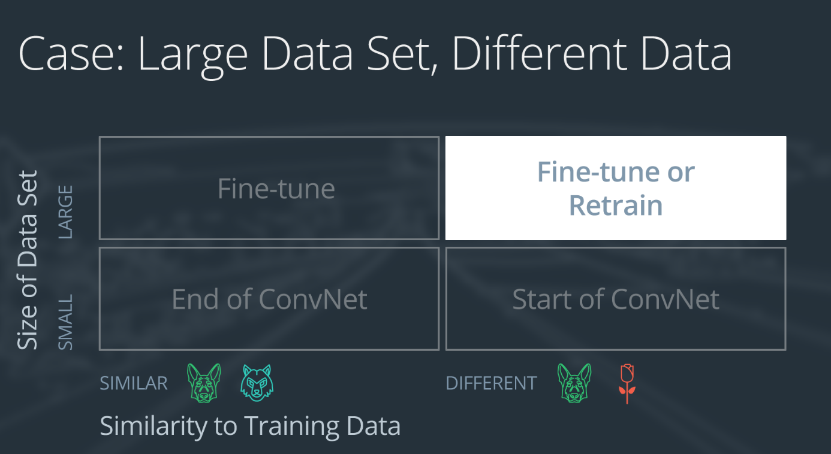](https://classroom.udacity.com/nanodegrees/nd101/parts/2e8d3b5d-aa70-4376-946f-0cdc37127d7d/modules/19a75d10-547d-4497-ae68-609ca1a235fc/lessons/a559990d-e214-4c5d-a424-437f6299383e/concepts/f80c5e76-e812-4bb0-aecd-40921aaf0bf6)](https://classroom.udacity.com/nanodegrees/nd101/parts/2e8d3b5d-aa70-4376-946f-0cdc37127d7d/modules/19a75d10-547d-4497-ae68-609ca1a235fc/lessons/a559990d-e214-4c5d-a424-437f6299383e/concepts/f80c5e76-e812-4bb0-aecd-40921aaf0bf6)**

**[Case 4: large data, different than original set](https://classroom.udacity.com/nanodegrees/nd101/parts/2e8d3b5d-aa70-4376-946f-0cdc37127d7d/modules/19a75d10-547d-4497-ae68-609ca1a235fc/lessons/a559990d-e214-4c5d-a424-437f6299383e/concepts/f80c5e76-e812-4bb0-aecd-40921aaf0bf6)**

If the new data set is large and different from the original training data:

* remove the last fully connected layer and replace with a layer matching the number of classes in the new data set
* retrain the network from scratch with randomly initialized weights
* alternatively, you could just use the same strategy as the "large and similar" data case

Even though the data set is different from the training data, initializing the weights from the pre-trained network might make training faster. So this case is exactly the same as the case with a large, similar data set.

If using the pre-trained network as a starting point does not produce a successful model, another option is to randomly initialize the convolutional neural network weights and train the network from scratch.

Here is how to visualize this approach:

**[[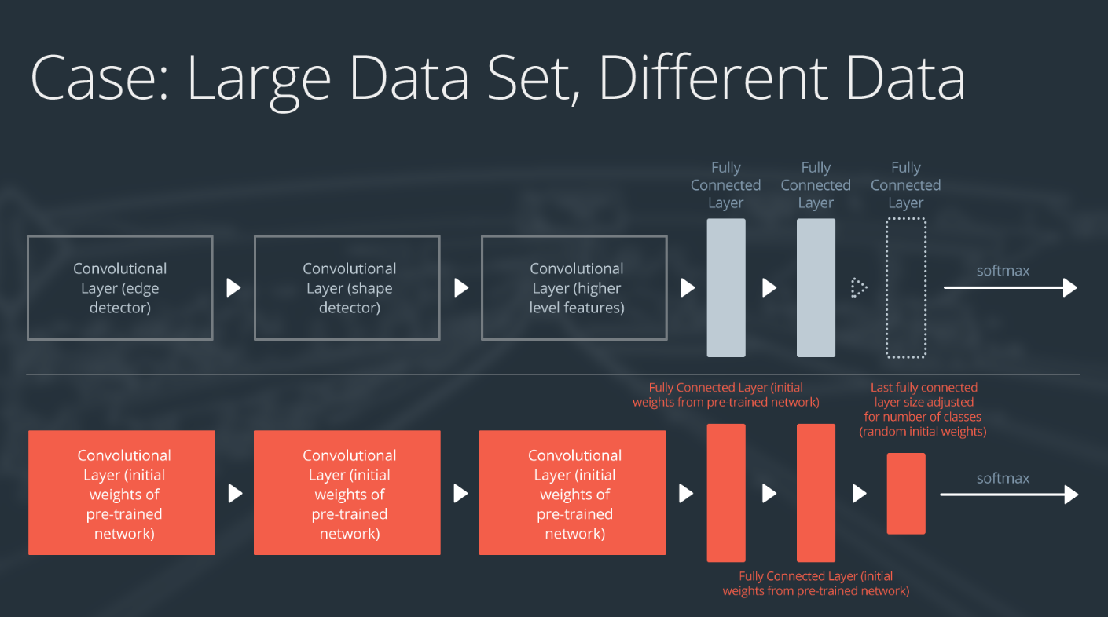](https://classroom.udacity.com/nanodegrees/nd101/parts/2e8d3b5d-aa70-4376-946f-0cdc37127d7d/modules/19a75d10-547d-4497-ae68-609ca1a235fc/lessons/a559990d-e214-4c5d-a424-437f6299383e/concepts/f80c5e76-e812-4bb0-aecd-40921aaf0bf6)](https://classroom.udacity.com/nanodegrees/nd101/parts/2e8d3b5d-aa70-4376-946f-0cdc37127d7d/modules/19a75d10-547d-4497-ae68-609ca1a235fc/lessons/a559990d-e214-4c5d-a424-437f6299383e/concepts/f80c5e76-e812-4bb0-aecd-40921aaf0bf6)**

**[Fine-tune or retrain entire network.](https://classroom.udacity.com/nanodegrees/nd101/parts/2e8d3b5d-aa70-4376-946f-0cdc37127d7d/modules/19a75d10-547d-4497-ae68-609ca1a235fc/lessons/a559990d-e214-4c5d-a424-437f6299383e/concepts/f80c5e76-e812-4bb0-aecd-40921aaf0bf6)**

# Autoencoders

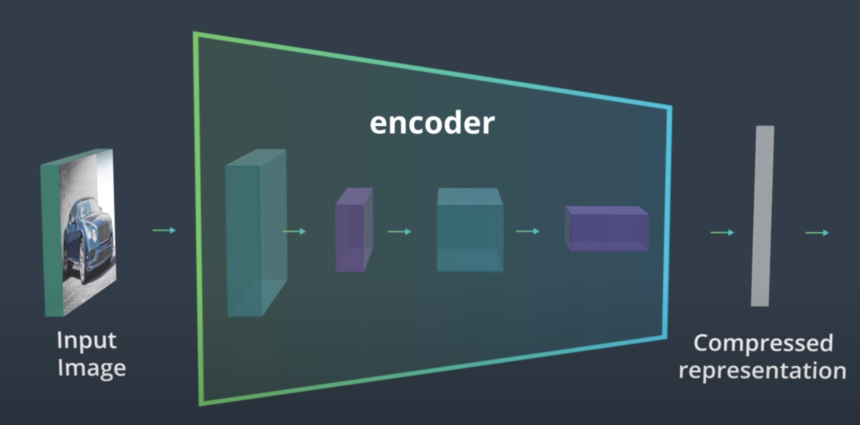

**Transpose Convolution**

This decoder uses **transposed convolutional** layers to increase the width and height of the input layers. They work almost exactly the same as convolutional layers, but in reverse. A stride in the input layer results in a larger stride in the transposed convolution layer. For example, if you have a 3x3 kernel, a 3x3 patch in the input layer will be reduced to one unit in a convolutional layer. Comparatively, one unit in the input layer will be expanded to a 3x3 path in a transposed convolution layer. PyTorch provides us with an easy way to create the layers, [nn.ConvTranspose2d](https://pytorch.org/docs/stable/nn.html#convtranspose2d).

It is important to note that transpose convolution layers can lead to artifacts in the final images, such as checkerboard patterns. This is due to overlap in the kernels which can be avoided by setting the stride and kernel size equal. In [this Distill article](http://distill.pub/2016/deconv-checkerboard/) from Augustus Odena, et al, the authors show that these checkerboard artifacts can be avoided by resizing the layers using nearest neighbor or bilinear interpolation (upsampling) followed by a convolutional layer.

**Upsampling + Convolutions, Decoder**

This decoder uses a combination of nearest-neighbor **upsampling and normal convolutional layers** to increase the width and height of the input layers.

It is important to note that transpose convolution layers can lead to artifacts in the final images, such as checkerboard patterns. This is due to overlap in the kernels which can be avoided by setting the stride and kernel size equal. In [this Distill article](http://distill.pub/2016/deconv-checkerboard/) from Augustus Odena, et al, the authors show that these checkerboard artifacts can be avoided by resizing the layers using nearest neighbor or bilinear interpolation (upsampling) followed by a convolutional layer. This is the approach we take, here.

<https://distill.pub/2016/deconv-checkerboard/>

# Style Transfer

<https://www.cv-foundation.org/openaccess/content_cvpr_2016/papers/Gatys_Image_Style_Transfer_CVPR_2016_paper.pdf>

Style transfer relies on separating the content and style of an image. Given one content image and one style image, we aim to create a new, *target* image which should contain our desired content and style components:

* objects and their arrangement are similar to that of the **content image**
* style, colors, and textures are similar to that of the **style image**

First we will pass both the content and style images through the VGG 19 network.

In the paper, the content representation for an image is taken as the output from the fourth Convolutional stack conv4,2

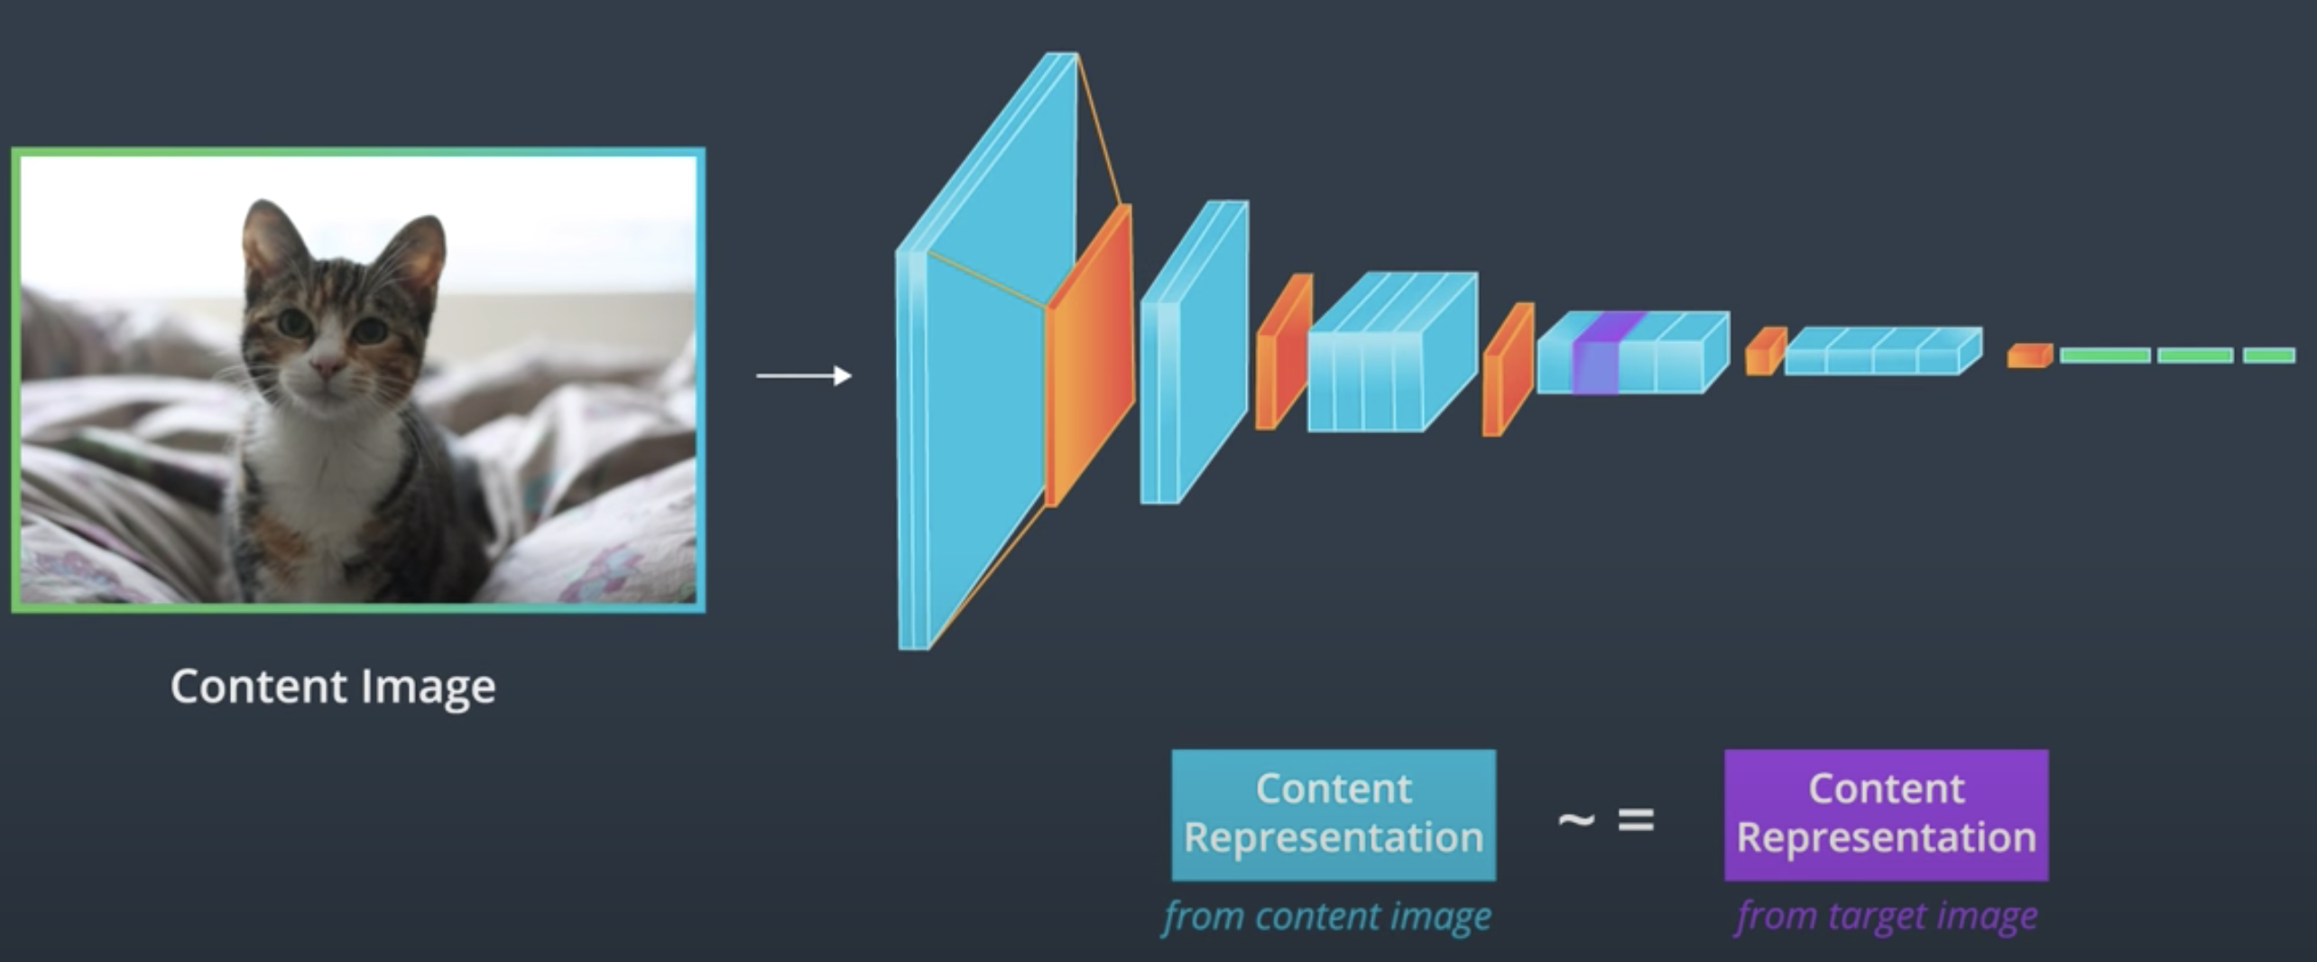

To visualise the image information that is encoded at different layers of the hierarchy one can perform gradient descent on a white noise image to find another image that matches the feature responses of the original image (Fig 1, content reconstructions) [24]. Let ~p and ~x be the original image and the image that is generated, and P l and F l their respective feature representation in layer l. We then define the squared-error loss between the two feature representations

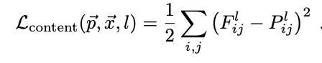

The style representation of an image relies on looking at correlation between the features and individual layers of the VGG-19 network. In other words, looking at how similar the features in a single layer are. By including the correlation between multiple layers of different sizes, we can obtain a multiscale style representation of the input image one that captures large and small style features. The style representation is calculated as an image passes through the network at the first convolutional layer in all 5 stacks. The correlations at each layer is given by a Gram matrix

For example, thinking at the style representation of this layer, we can say that this layer has 8 feature maps we want to find the relationship between.

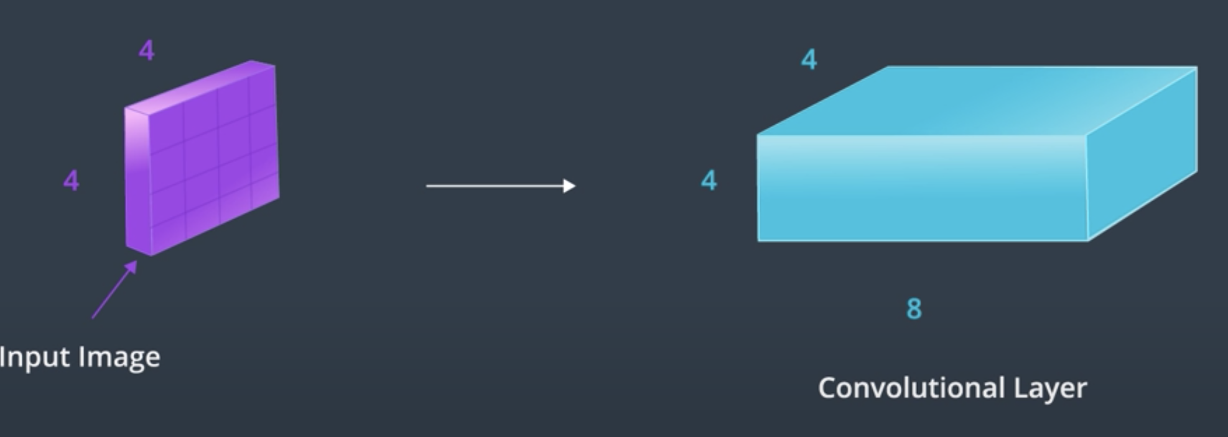

The first step in calculating the Gram matrix, will be to vectorize the value in this layer .

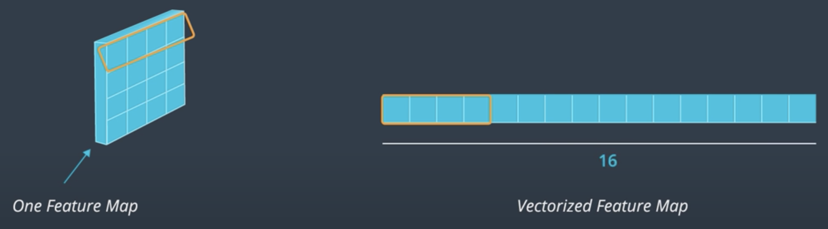

By flattening the XY dimensions of the feature maps, we are converting a 3d convolutional layer into a 2d matrix of values

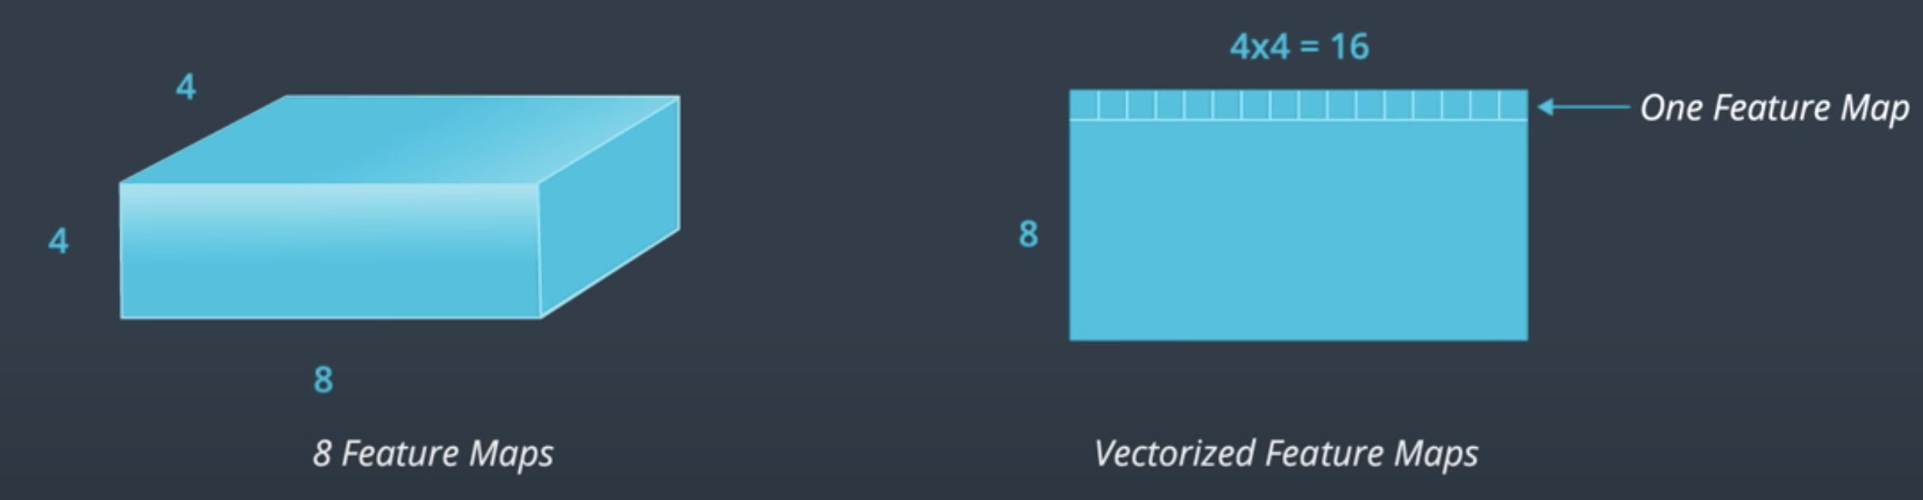

The next step is to multiply this matrix by it’s transpose. Essentially, by multiplying the features in each map to get the gram matrix. As a result, the Gram matrix contains non-localized information (Information that will still be there even if an image was shuffled around in space) about the layer. For example, even if the content of a filtered image is not identifiable, you should still be able to see prominent colors and textures in the style

Finally, we are left with the square eight by eight Gram matrix, whose values indicate the similarity between the layers. For example, the value highlighted indicate the similarity between the second and fourth feature maps in a layer. Importantly, the dimensions of the matrix are related only to the number of feature maps in the convolutional layer, it doesn’t depend on the dimensions of the input image. Note that the Gram matrix is just one mathematical way of representing the idea of shared and prominent styles.

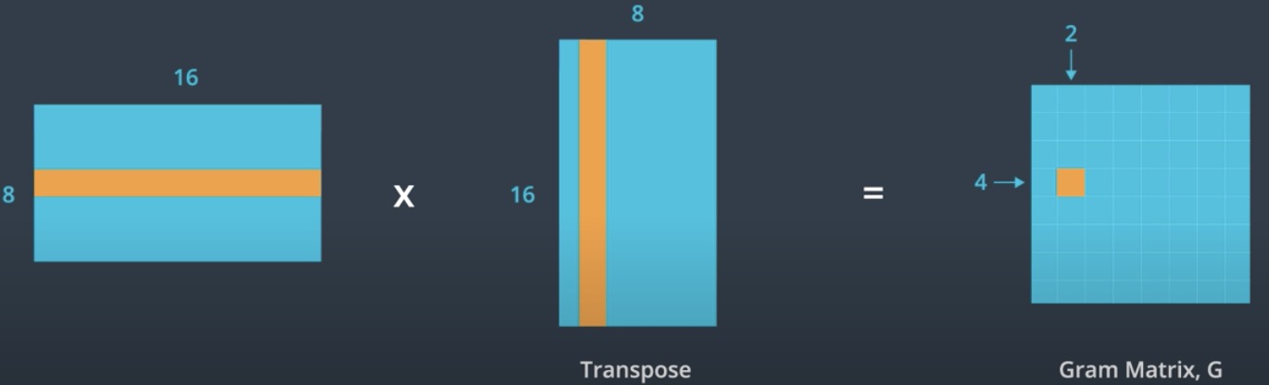

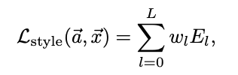

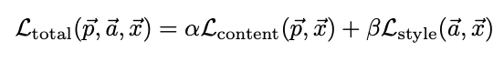

Since the content and style loss are calculated differently, we scale it using a and b constants so that the total loss takes both into account fairly equally. Often b is much larger. Of course, image content and style cannot be completely disentangled. When synthesising an image that combines the content of one image with the style of another, there usually does not exist an image that perfectly matches both constraints at the same time. However, since the loss function we minimise during image synthesis is a linear combination between the loss functions for content and style respectively, we can smoothly regulate the emphasis on either reconstructing the content or the style (Fig 4). A strong emphasis on style will result in images that match the appearance of the artwork, effectively giving a texturised version of it, but show hardly any of the photograph’s content (α/β = 1 × 10−4 , Fig 4, top left). When placing strong emphasis on content, one can clearly identify the photograph, but the style of the painting is not as well-matched (α/β = 1 × 10−1 , Fig 4, bottom right). For a specific pair of content and style images one can adjust the trade-off between content and style to create visually appealing images.

